Translating Verbal Expressions to Variable Expressions
Many algebra textbooks, including ours, have exercises involving translating verbal expressions into variable expressions. I have found that there are two things that give students difficulties with these problems.
- They try to translate them word for word in the order that they are written in words and due to the richness of natural languages, this doesn't always work.
- Complicated things can be written in algebraic notation that are difficult to write about in language, and because of this, the verbal expressions can get very complicated and it can be difficult to tell where the grouping is.
The first of these occurs partly because many well meaning instructors have encouraged it, and with some justification, because it can indeed be made to work in many cases and it can indeed be helpful to learn what operations certain keywords normally with which operations. Here is a partial list of keywords to look for along with the operations that they suggest, but you should keep in mind they should only alert you that the operation is probably involved.
plus, more, increased, total, add, sum | +
minus, less, decreased, subtract, difference | -
times, of, multiply, double, twice, product | x
divided by, quotient | /
In particular the words sum, difference, product, and quotient are particularly important in that they are the standard words for the answers to each of the operations, and it is worth noting that the following translation always works.
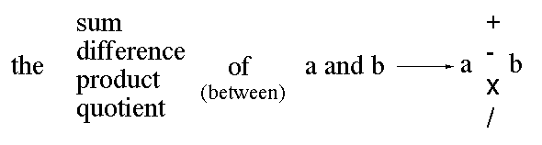
But the problem with taking this sort of translation technique too far is that you are ever having to make up rules for the many and varied ways the language uses to express these things, when as a native speaker you really perfectly well know what the language means, and besides this sort of loses part of the point of the exercise of helping you understand what variable expressions mean. The really best way to translate verbal expressions into variable expressions is to think about what the verbal expression means, and then think about how you would compute that if you were given numbers.

Example
Problem: Translate '5 less than x' to a variable expression.
Solution: This example is a very good example of what I have been talking about, because if you tranlate it word for word you get 5-x, which is wrong. But instead think about how you would compute the number that is 5 less than 17. You wouldn't compute 5-17, you would compute 17-5. Now if you write the same thing down with x, you get the right answer of x-5.
Now to the second difficulty, dealing with complicated wording where there is more than one operation.

Examples
- the sum of the product of five and a number and the product of seven and another number
- a number plus the product of the number and nine
- the difference between a number and the total of three times the number and six
1. First, start reading the expression, "the sum of the product of five and a number", and the first part of it that will stand alone is 'the product of five and a number', so we will put parentheses around it. Going on, "the sum of the product of five and a number and the product of seven and another number". 'the product of seven and another number' will also stand alone, so we would write the expression like this:
the sum of (the product of five and a number) and (the product of seven and another number)
Now write variable expressions for each of the expressions in the parentheses.
For the first one we get 5x and for the second one we get 7y. From here you may be able to see what to do. If not replace the parentheses with your variable expressions and write
the sum of 5x and 7y
and now it should become clear that the whole thing can be written as 5x+7y.
2. "a number plus the product of the number and nine", and I don't get to anything that will stand alone until the end, 'the product of the number and nine'. Put parentheses around this and the expression looks like this.
a number plus (the product of the number and nine)
'product of the number and nine' can be written 9x, so then the expression becomes
a number plus 9x
which can be written x+9x. Simplifying this we get 10x.

