Squares and Square Roots

How to Square A Number
To square a number, just multiply it by itself ...

Example: What is 3 squared?
3 Squared | = | 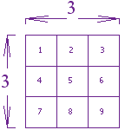 | = 3 × 3 = 9

"Squared" is often written as a little 2 like this:
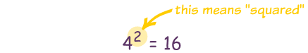
This says "4 Squared equals 16"
(the little 2 says the number appears twice in multiplying)

Squares From 1² to 6²
1 Squared | = | 1² | = | 1 × 1 | = | 1
2 Squared | = | 2² | = | 2 × 2 | = | 4
3 Squared | = | 3² | = | 3 × 3 | = | 9
4 Squared | = | 4² | = | 4 × 4 | = | 16
5 Squared | = | 5² | = | 5 × 5 | = | 25
6 Squared | = | 6² | = | 6 × 6 | = | 36

Square Roots
A square root goes the other way:
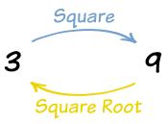
3 squared is 9, so a square root of 9 is 3

A square root of a number is ...
... a value that can be multiplied by itself to give the original number.
A square root of 9 is ...
... 3, because when 3 is multiplied by itself you get 9.
It is like asking:
What can I multiply by itself to get this?
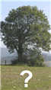 | To help you remember think of the root of a tree:  "I know the tree, but what is the root that produced it?"  In this case the tree is "9", and the root is "3".
√9 = 3
Because $3^{2}$ = 9

The Square Root Symbol
This is the special symbol that means "square root", it is sort of like a tick, and actually started hundreds of years ago as a dot with a flick upwards.
It is called the radical, and always makes math look important!
You can use it like this:
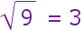
you would say "square root of 9 equals 3"

Example: What is √25?
Well, we just happen to know that 25 = 5 × 5, so if you multiply 5 by itself (5 × 5) you will get 25.
So the answer is:
√25 = 5

Example: What is √36 ?
Answer: 6 × 6 = 36, so √36 = 6

Perfect Squares
The perfect squares are the squares of the whole numbers:
 | 1 | 2 | 3 | 4 | 5 | 6 | 7 | 8 | 9 | 10 | 11 | 12 | 13 | 14 | 15 | etc
Perfect Squares: | 1 | 4 | 9 | 16 | 25 | 36 | 49 | 64 | 81 | 100 | 121 | 144 | 169 | 196 | 225 | ...

Calculating Square Roots

If the square root is NOT one of the perfect squares, you must determine the two consecutive numbers that it falls between.

Example: what is √10?
Well, 3 × 3 = 9 and 4 × 4 = 16, so the square root is between 3 and 4.
Note: numbers like that are called Irrational Numbers, if you want to know more.

